AMERICAN INTERNATIONAL UNIVERSITY–BANGLADESH (AIUB)

**FACULTY OF SCIENCE & TECHNOLOGY**

Project

**Course Name: - Introduction to Database**

Section: - ‘L’

Semester: Fall 2022-23

**Group No : 04**

Project Name: A Gaming Community Management

Supervised by: - MD SAJID BIN-FAISAL

**[ Lecturer,**

**Faculty of Science & Technology, AIUB]**

**Submitted by:**

|  |  |
| --- | --- |
| NAME | ID |
| RIAD AL HASAN | **22-46732-1** |
| SUMAIYA ISLAM | **22-47303-1** |
| SOURAV SAHA | **22-46737-1** |
| OBAIDUL HASAN SHAKIB | **22-46143-1** |

**Submitted** Date: - 14-12-2022

|  |
| --- |
| Project Name |
| A Gaming Community Management System |

**Project Theme:** A relational database management system of gaming community.

**Table of Content**

* Introduction
* ER-Diagram
* Normalization
* Finalization
* Table Creation
* Data Insertion
* Query Test
* Joining
* Viewing
* Conclusion

**Introduction**

Gaming community management system is project which is helpful for players as well as the authorities. Our Gaming community management system deals with the various activities related to the different games player. It is very time consuming and costly.

A gaming community management system has so many benefits.

Here,

* There are many types of games with many types of players managed by managers and moderators.
* Different types of tournaments are organized, there are prize pools.
* Any other community can hire players if they want.
* Can competes with other community players.

It can easily access to the data. That's why the community can be managed very well.

**Scenario Description**

A gaming community owners want to build a database management system to manage their community. There are three games for this management namely PUBG, VALORANT and CALL OF DUTY. There are many players to play this game. PUBG player has attributes like p_name, p_id, p_level, p_role, p_sal, p_joindate, p_number and p_location. VALORANT players have attributes like v_name, v_id, v_level, v_role, v_sal, v_joindate, v_number and v_ location. CALL OF DUTY players have attributes like cod_name, cod _id, cod _level, cod _role, cod _sal, cod _joindate, cod _number and cod _ location. There is a tournament for PUBG and VALORANT where multiple teams are selections. Tournament has attributes like name and p_money. A tournament will have 16 teams from PUBG and 20 teams from VALORANT will qualified. A team will have Maximum six players. CALL OF DUTY is newly added to the community that’s why Several teams will be created with many players from CALL OF DUTY. A team will have Maximum six players. The teams have attributes like t_name, t_id, t_position and t_score. Each teams have some moderators to take care of players and teach the games trick. A team will have a moderator. Managers are there to guide the moderator’s and manage the team properly. The moderator has attributes like mo_name, mo_id, mo_sal, mo_number, mo_gamename and mo_joindate. The manager has attributes like m_name, m_id, m_sal, m_number, m_gamename and m_joindate. Moderator’s reports to manager. A manager can check performance for tournament of teams and moderators. A manager controls many moderators. Others PUBG teams can compete with our communities PUBG teams for this need to manager permission. For PUBG Competes with others community attributes like co_name, co_id and play_date. Any community that can hire a VALORANT players. The community attributes like hco_name, hco_id. The community will identify the player hire date.

**ER-Diagram**



**Normalization**

 Foreign key

 Primary key

* **Contests:**



|  |  |  |  |  |  |  |  |
| --- | --- | --- | --- | --- | --- | --- | --- |
| **p_id** | p_name | p_level | p_sal | p_role | p_number | P_joindate | P_location |
| p_money | **name** |

UNF:

|  |  |  |  |  |  |  |  |
| --- | --- | --- | --- | --- | --- | --- | --- |
| **p_id** | p_name | p_level | p_sal | p_role | p_number | P_joindate | P_location |
| p_money | **name** |

1NF:

|  |  |  |  |  |  |  |  |
| --- | --- | --- | --- | --- | --- | --- | --- |
| **p_id** | p_name | p_level | p_sal | p_role | p_number | P_joindate | P_location |

2NF:

|  |  |
| --- | --- |
| p_money | **name** |
|

|  |  |  |  |  |  |  |  |
| --- | --- | --- | --- | --- | --- | --- | --- |
| **p_id** | p_name | p_level | p_sal | p_role | p_number | P_joindate | P_location |
| **name** |  |

3NF: As Same As 2NF

* **Qualifies:**

UNF:

|  |  |  |  |  |  |
| --- | --- | --- | --- | --- | --- |
| **name** | p_money | **Pt_id** | Pt_name | Pt_score | Pt_position |

1NF:

|  |  |  |  |  |  |
| --- | --- | --- | --- | --- | --- |
| **name** | p_money | **Pt_id** | Pt_name | Pt_score | Pt_position |

2NF:

|  |  |
| --- | --- |
| **name** | p_money |

|  |  |  |  |  |
| --- | --- | --- | --- | --- |
| **Pt_id** | Pt_name | Pt_score | Pt_position | **name** |

3NF: As Same As 2NF

* **Sports:**

UNF:

|  |  |  |  |  |  |  |  |
| --- | --- | --- | --- | --- | --- | --- | --- |
| **Pt_id** | Pt_name | Pt_score | Pt_position | **p_id** | p_name | p_level | p_sal |
| p_role | p_number | P_joindate | P_location |  | | | |

1NF:

|  |  |  |  |  |  |  |  |
| --- | --- | --- | --- | --- | --- | --- | --- |
| **Pt_id** | Pt_name | Pt_score | Pt_position | **p_id** | p_name | p_level | p_sal |
| p_role | p_number | P_joindate | P_location |  | | | |

2NF:

|  |  |  |  |
| --- | --- | --- | --- |
| **Pt_id** | Pt_name | Pt_score | Pt_position |

|  |  |  |  |  |  |  |  |
| --- | --- | --- | --- | --- | --- | --- | --- |
| **p_id** | p_name | p_level | p_sal | p_role | p_number | P_joindate | P_location |

|  |  |
| --- | --- |
| **p_id** | **Pt_id** |

3NF: As Same As 2NF

* **Tricks:**

UNF:

|  |  |  |  |  |  |  |  |  |
| --- | --- | --- | --- | --- | --- | --- | --- | --- |
| **Pt_id** | Pt_name | Pt_score | Pt_position | **mo_id** | mo_name | | mo_number | m_sal |
| mo_joindate | mo_gamename |  | | | |

1NF:

|  |  |  |  |  |  |  |  |  |
| --- | --- | --- | --- | --- | --- | --- | --- | --- |
| **Pt_id** | Pt_name | Pt_score | Pt_position | **mo_id** | mo_name | | mo_number | p_sal |
| mo_joindate | mo_gamename |  | | | |

2NF:

|  |  |  |  |
| --- | --- | --- | --- |
| **Pt_id** | Pt_name | Pt_score | Pt_position |

|  |  |  |  |  |  |  |
| --- | --- | --- | --- | --- | --- | --- |
| **mo_id** | mo_name | mo_number | mo_sal | mo_joindate | mo_gamename | |
|  | | | | | |

|  |  |
| --- | --- |
| **mo_id** | **Pt_id** |

3NF: As Same As 2NF

* **Counsellors:**

UNF:

|  |  |  |  |  |  |  |  |  |
| --- | --- | --- | --- | --- | --- | --- | --- | --- |
| **mo_id** | mo_name | mo_sal | mo_number | mo_joindate | mo_gamename | | **m_id** | m_name |
| m_joindate | mo_gamename | m_sal | m_number |  | |

1NF:

|  |  |  |  |  |  |  |  |  |
| --- | --- | --- | --- | --- | --- | --- | --- | --- |
| **mo_id** | mo_name | mo_sal | mo_number | mo_joindate | mo_gamename | | **m_id** | m_name |
| m_joindate | m_gamename | m_sal | m_number |  | |

2NF:

|  |  |  |  |  |  |
| --- | --- | --- | --- | --- | --- |
| **mo_id** | mo_name | mo_number | mo_sal | mo_joindate | mo_gamename |

|  |  |  |  |  |  |  |
| --- | --- | --- | --- | --- | --- | --- |
| **m_id** | m_name | m_sal | m_number | m_joindate | m_gamename | **Mo_id** |

3NF: As Same As 2NF

* **Battles:**

|  |  |  |  |  |  |  |  |
| --- | --- | --- | --- | --- | --- | --- | --- |
| **v_id** | v_name | v_level | v_sal | v_role | v_number | v_joindate | v_location |
| p_money | **name** |

UNF:

1NF:

|  |  |  |  |  |  |  |  |
| --- | --- | --- | --- | --- | --- | --- | --- |
| **v_id** | v_name | v_level | v_sal | v_role | v_number | v_joindate | v_location |
| p_money | **name** |

|  |  |  |  |  |  |  |  |
| --- | --- | --- | --- | --- | --- | --- | --- |
| **v_id** | v_name | v_level | v_sal | v_role | v_number | v_joindate | v_location |

2NF:

|  |  |
| --- | --- |
| p_money | **name** |
|

|  |  |  |  |  |  |  |  |
| --- | --- | --- | --- | --- | --- | --- | --- |
| **v_id** | v_name | v_level | v_sal | v_role | v_number | v_joindate | v_location |
| **name** |  |

3NF: As Same As 2NF

* **Merits:**

UNF:

|  |  |  |  |  |  |
| --- | --- | --- | --- | --- | --- |
| **name** | p_money | **Vt_id** | Vt_name | Vt_score | Vt_position |

1NF:

|  |  |  |  |  |  |
| --- | --- | --- | --- | --- | --- |
| **name** | p_money | **Vt_id** | Vt_name | Vt_score | Vt_position |

2NF:

|  |  |
| --- | --- |
| **name** | p_money |

|  |  |  |  |  |
| --- | --- | --- | --- | --- |
| **Vt_id** | Vt_name | Vt_score | Vt_position | **name** |

3NF: As Same As 2NF

* **Funs:**

UNF:

|  |  |  |  |  |  |  |  |
| --- | --- | --- | --- | --- | --- | --- | --- |
| **Vt_id** | Vt_name | Vt_score | Vt_position | **v_id** | v_name | v_level | v_sal |
| v_role | v_number | v_joindate | v_location |  | | | |

1NF:

|  |  |  |  |  |  |  |  |
| --- | --- | --- | --- | --- | --- | --- | --- |
| **Vt_id** | Vt_name | Vt_score | Vt_position | **v_id** | v_name | v_level | v_sal |
| v_role | v_number | v_joindate | v_location |  | | | |

2NF:

|  |  |  |  |
| --- | --- | --- | --- |
| **Vt_id** | Vt_name | Vt_score | Vt_position |

|  |  |  |  |  |  |  |  |
| --- | --- | --- | --- | --- | --- | --- | --- |
| **v_id** | v_name | v_level | v_sal | v_role | v_number | v_joindate | v_location |

|  |  |
| --- | --- |
| **v_id** | **Vt_id** |

3NF: As Same As 2NF

* **Techniques:**

UNF:

|  |  |  |  |  |  |  |  |  |
| --- | --- | --- | --- | --- | --- | --- | --- | --- |
| **Vt_id** | Vt_name | Vt_score | Vt_position | **mo_id** | mo_name | | mo_number | m_sal |
| mo_joindate | mo_gamename |  | | | |

1NF:

|  |  |  |  |  |  |  |  |  |
| --- | --- | --- | --- | --- | --- | --- | --- | --- |
| **Vt_id** | Vt_name | Vt_score | Vt_position | **mo_id** | mo_name | | mo_number | p_sal |
| mo_joindate | mo_gamename |  | | | |

2NF:

|  |  |  |  |
| --- | --- | --- | --- |
| **Vt_id** | Vt_name | Vt_score | Vt_position |

|  |  |  |  |  |  |  |
| --- | --- | --- | --- | --- | --- | --- |
| **mo_id** | mo_name | mo_number | m_sal | mo_joindate | mo_gamename | |
|  | | | | | |

|  |  |
| --- | --- |
| **mo_id** | **Vt_id** |

3NF: As Same As 2NF

* **Advisors:**

UNF:

|  |  |  |  |  |  |  |  |  |
| --- | --- | --- | --- | --- | --- | --- | --- | --- |
| **mo_id** | mo_name | mo_sal | mo_number | mo_joindate | mo_gamename | | **m_id** | m_name |
| m_joindate | m_gamename | m_sal | m_number |  | |

1NF:

|  |  |  |  |  |  |  |  |  |
| --- | --- | --- | --- | --- | --- | --- | --- | --- |
| **mo_id** | mo_name | mo_sal | mo_number | mo_joindate | mo_gamename | | **m_id** | m_name |
| m_joindate | mo_gamename | m_sal | m_number |  | |

2NF:

|  |  |  |  |  |  |
| --- | --- | --- | --- | --- | --- |
| **mo_id** | mo_name | mo_number | mo_sal | mo_joindate | mo_gamename |

|  |  |  |  |  |  |  |
| --- | --- | --- | --- | --- | --- | --- |
| **m_id** | m_name | m_sal | m_number | m_joindate | m_gamename | **Mo_id** |

3NF: As Same As 2NF

* **Checks:**

UNF:

|  |  |  |  |  |  |  |
| --- | --- | --- | --- | --- | --- | --- |
| **m_id** | m_name | m_sal | m_number | m_joindate | m_gamename | **mo_id** |
| mo_name | mo_sal | mo_number | mo_joindate | mo_gamename | **Vt_id** | Vt_name |
| Vt_score | Vt_position | **Pt_id** | Pt_name | Pt_score | Pt_position |  |

1NF:

|  |  |  |  |  |  |  |
| --- | --- | --- | --- | --- | --- | --- |
| **m_id** | m_name | m_sal | m_number | m_joindate | m_gamename | **mo_id** |
| mo_name | mo_sal | mo_number | mo_joindate | mo_gamename | **Vt_id** | Vt_name |
| Vt_score | Vt_position | **Pt_id** | Pt_name | Pt_score | Pt_position |  |

2NF:

|  |  |  |  |  |  |  |  |
| --- | --- | --- | --- | --- | --- | --- | --- |
| **m_id** | m_name | m_sal | | m_number | m_joindate | m_gamename | **mo_id** |
| mo_name | mo_sal | mo_number | | mo_joindate | mo_gamename | **Vt_id** | Vt_name |
| Vt_score | Vt_position |  |

|  |  |  |  |  |  |  |  |
| --- | --- | --- | --- | --- | --- | --- | --- |
| **m_id** | m_name | m_sal | | m_number | m_joindate | m_gamename | **mo_id** |
| mo_name | mo_sal | mo_number | | mo_joindate | mo_gamename | **Pt_id** | Pt_name |
| Pt_score | Pt_position |  |

|  |  |
| --- | --- |
| **Vt_id** | **m_id** |

|  |  |
| --- | --- |
| **Pt_id** | **m_id** |

3NF: As Same As 2NF

* **Permissions:**

UNF:

|  |  |  |  |  |  |  |
| --- | --- | --- | --- | --- | --- | --- |
| **m_id** | m_name | m_sal | m_number | m_joindate | m_gamename | **Pt_id** |
| Pt_name | Pt_score | Pt_position |

1NF:

|  |  |  |  |  |  |  |
| --- | --- | --- | --- | --- | --- | --- |
| **m_id** | m_name | m_sal | m_number | m_joindate | m_gamename | **Pt_id** |
| Pt_name | Pt_score | Pt_position |

2NF:

|  |  |  |  |  |  |
| --- | --- | --- | --- | --- | --- |
| **m_id** | m_name | m_sal | m_number | m_joindate | m_gamename |

|  |  |  |  |  |
| --- | --- | --- | --- | --- |
| **Pt_id** | Pt_name | Pt_score | Pt_position | **m_id** |

3NF: As Same As 2NF

* **Competes:**

UNF:

|  |  |  |  |  |  |  |
| --- | --- | --- | --- | --- | --- | --- |
| **Pt_id** | Pt_name | Pt_score | Pt_position | play_date | co_name | **co_id** |

1NF:

|  |  |  |  |  |  |  |
| --- | --- | --- | --- | --- | --- | --- |
| **Pt_id** | Pt_name | Pt_score | Pt_position | **co_id** | co_name | play_date |

2NF:

|  |  |  |  |
| --- | --- | --- | --- |
| **Pt_id** | Pt_name | Pt_score | Pt_position |

|  |  |  |
| --- | --- | --- |
| **co_id** | co_name | play_date |

|  |  |
| --- | --- |
| **Pt_id** | **co_id** |

3NF: As Same As 2NF

* **Reports:**

UNF:

|  |  |  |  |  |  |  |  |  |
| --- | --- | --- | --- | --- | --- | --- | --- | --- |
| **mo_id** | mo_name | mo_sal | mo_number | mo_joindate | mo_gamename | | **m_id** | m_name |
| m_joindate | m_gamename | m_sal | m_number |  | |

1NF:

|  |  |  |  |  |  |  |  |  |
| --- | --- | --- | --- | --- | --- | --- | --- | --- |
| **mo_id** | mo_name | mo_sal | mo_number | mo_joindate | mo_gamename | | **m_id** | m_name |
| m_joindate | mo_gamename | m_sal | m_number |  | |

2NF:

|  |  |  |  |  |  |
| --- | --- | --- | --- | --- | --- |
| **mo_id** | mo_name | mo_number | mo_sal | mo_joindate | mo_gamename |

|  |  |  |  |  |  |  |
| --- | --- | --- | --- | --- | --- | --- |
| **m_id** | m_name | m_sal | m_number | m_joindate | m_gamename | **Mo_id** |

3NF: As Same As 2NF

* **Hires:**

UNF:

|  |  |  |  |  |  |  |
| --- | --- | --- | --- | --- | --- | --- |
| **v_id** | v_name | v_level | v_sal | v_role | v_number | v_joindate |
| v_location | hco_id | hco_name | hiredate |

1NF:

|  |  |  |  |  |  |  |
| --- | --- | --- | --- | --- | --- | --- |
| **v_id** | v_name | v_level | v_sal | v_role | v_number | v_joindate |
| v_location | **hco_id** | hco_name | hiredate |

2NF:

|  |  |  |  |  |  |  |
| --- | --- | --- | --- | --- | --- | --- |
| **v_id** | v_name | v_level | v_sal | v_role | v_number | v_joindate |
| v_location |

|  |  |  |
| --- | --- | --- |
| **hco_id** | hco_name | hiredate |

|  |  |
| --- | --- |
| **v_id** | **hco_id** |

3NF: As Same As 2NF

* **Creates:**

UNF:

|  |  |  |  |  |  |  |  |  |
| --- | --- | --- | --- | --- | --- | --- | --- | --- |
| **CODt_id** | CODt_name | CODt_score | CODt_position | **cod_id** | cod_name | cod _level | cod _sal | |
| cod _role | cod _number | cod _joindate | cod _location |  | | | |

1NF:

|  |  |  |  |  |  |  |  |  |
| --- | --- | --- | --- | --- | --- | --- | --- | --- |
| **CODt_id** | CODt_name | CODt_score | CODt_position | **cod_id** | cod_name | cod _level | cod _sal | |
| cod _role | cod _number | cod _joindate | cod _location |  | | | |

2NF:

|  |  |  |  |
| --- | --- | --- | --- |
| **CODt_id** | CODt_name | CODt_score | CODt_position |

|  |  |  |  |  |  |  |  |
| --- | --- | --- | --- | --- | --- | --- | --- |
| **cod_id** | cod_name | cod _level | cod _sal | cod _role | cod _number | cod _joindate | cod _location |

|  |  |
| --- | --- |
| **cod_id** | **CODt_id** |

3NF: As Same As 2NF

* **Styles:**

UNF:

|  |  |  |  |  |  |  |  |  |
| --- | --- | --- | --- | --- | --- | --- | --- | --- |
| **CODt_id** | CODt_name | CODt_score | CODt_position | **mo_id** | mo_name | | mo_number | m_sal |
| mo_joindate | mo_gamename |  | | | |

1NF:

|  |  |  |  |  |  |  |  |  |
| --- | --- | --- | --- | --- | --- | --- | --- | --- |
| **CODt_id** | CODt_name | CODt_score | CODt_position | **mo_id** | mo_name | | mo_number | m_sal |
| mo_joindate | mo_gamename |  | | | |

2NF:

|  |  |  |  |
| --- | --- | --- | --- |
| **CODt_id** | CODt_name | CODt_score | CODt_position |

|  |  |  |  |  |  |  |
| --- | --- | --- | --- | --- | --- | --- |
| **mo_id** | mo_name | mo_number | m_sal | mo_joindate | mo_gamename | |
| |  |  | | --- | --- | | **mo_id** | **CODt_id** | | | | | | |

3NF: As Same As 2NF

* **Plays:**

UNF:

|  |  |  |  |  |  |  |  |  |
| --- | --- | --- | --- | --- | --- | --- | --- | --- |
| **CODt_id** | CODt_name | CODt_score | CODt_position | **cod_id** | cod_name | cod _level | cod _sal | |
| cod _role | cod _number | cod _joindate | cod _location |  | | | |

1NF:

|  |  |  |  |  |  |  |  |  |
| --- | --- | --- | --- | --- | --- | --- | --- | --- |
| **CODt_id** | CODt_name | CODt_score | CODt_position | **cod_id** | cod_name | cod _level | cod _sal | |
| cod _role | cod _number | cod _joindate | cod _location |  | | | |

2NF:

|  |  |  |  |
| --- | --- | --- | --- |
| **CODt_id** | CODt_name | CODt_score | CODt_position |

|  |  |  |  |  |  |  |  |
| --- | --- | --- | --- | --- | --- | --- | --- |
| **cod_id** | cod_name | cod _level | cod _sal | cod _role | cod _number | cod _joindate | cod _location |

|  |  |
| --- | --- |
| **cod_id** | **CODt_id** |

3NF: As Same As 2NF

* **Guides:**

UNF:

|  |  |  |  |  |  |  |  |  |
| --- | --- | --- | --- | --- | --- | --- | --- | --- |
| **mo_id** | mo_name | mo_sal | mo_number | mo_joindate | mo_gamename | | **m_id** | m_name |
| m_joindate | m_gamename | m_sal | m_number |  | |

1NF:

|  |  |  |  |  |  |  |  |  |
| --- | --- | --- | --- | --- | --- | --- | --- | --- |
| **mo_id** | mo_name | mo_sal | mo_number | mo_joindate | mo_gamename | | **m_id** | m_name |
| m_joindate | mo_gamename | m_sal | m_number |  | |

2NF:

|  |  |  |  |  |  |
| --- | --- | --- | --- | --- | --- |
| **mo_id** | mo_name | mo_number | mo_sal | mo_joindate | mo_gamename |

|  |  |  |  |  |  |  |
| --- | --- | --- | --- | --- | --- | --- |
| **m_id** | m_name | m_sal | m_number | m_joindate | m_gamename | **Mo_id** |

3NF: As Same As 2NF

* **Responses:**

UNF:

|  |  |  |  |  |  |  |  |  |
| --- | --- | --- | --- | --- | --- | --- | --- | --- |
| **mo_id** | mo_name | mo_sal | mo_number | mo_joindate | mo_gamename | | **m_id** | m_name |
| m_joindate | m_gamename | m_sal | m_number |  | |

1NF:

|  |  |  |  |  |  |  |  |  |
| --- | --- | --- | --- | --- | --- | --- | --- | --- |
| **mo_id** | mo_name | mo_sal | mo_number | mo_joindate | mo_gamename | | **m_id** | m_name |
| m_joindate | mo_gamename | m_sal | m_number |  | |

2NF:

|  |  |  |  |  |  |
| --- | --- | --- | --- | --- | --- |
| **mo_id** | mo_name | mo_number | mo_sal | mo_joindate | mo_gamename |

|  |  |  |  |  |  |  |
| --- | --- | --- | --- | --- | --- | --- |
| **m_id** | m_name | m_sal | m_number | m_joindate | m_gamename | **Mo_id** |

3NF: As Same As 2NF

**Finalization**

\

**Finalization:**

 Foreign key

 Primary key

* **PUBG:**

|  |  |  |  |  |  |  |  |
| --- | --- | --- | --- | --- | --- | --- | --- |
| **p_id** | p_name | p_level | p_sal | p_role | p_number | P_joindate | P_location |

* **TOURNAMENT:**

|  |  |
| --- | --- |
| p_money | **name** |
|

* **Contests:**

|  |  |  |  |  |  |  |  |
| --- | --- | --- | --- | --- | --- | --- | --- |
| **p_id** | p_name | p_level | p_sal | p_role | p_number | P_joindate | P_location |
| **name** |  |

* **QUALIFY:**

|  |  |  |  |  |
| --- | --- | --- | --- | --- |
| **Pt_id** | Pt_name | Pt_score | Pt_position | **name** |

* **PUBG_TEAM:**

|  |  |  |  |
| --- | --- | --- | --- |
| **Pt_id** | Pt_name | Pt_score | Pt_position |

* **SPORTS:**

|  |  |
| --- | --- |
| **p_id** | **Pt_id** |

* **MODERATOR:**

|  |  |  |  |  |  |  |
| --- | --- | --- | --- | --- | --- | --- |
| **mo_id** | mo_name | mo_number | mo_sal | mo_joindate | mo_gamename | |
|  | | | | | |

* **TRICK:**

|  |  |
| --- | --- |
| **mo_id** | **Pt_id** |

|  |  |  |  |  |  |  |
| --- | --- | --- | --- | --- | --- | --- |
| **m_id** | m_name | m_sal | m_number | m_joindate | m_gamename | **Mo_id** |

* **COUNSELLOR:**
* **VALORANT:**

|  |  |  |  |  |  |  |  |
| --- | --- | --- | --- | --- | --- | --- | --- |
| **v_id** | v_name | v_level | v_sal | v_role | v_number | v_joindate | v_location |

* **BATTLE:**

|  |  |  |  |  |  |  |  |
| --- | --- | --- | --- | --- | --- | --- | --- |
| **v_id** | v_name | v_level | v_sal | v_role | v_number | v_joindate | v_location |
| **name** |  |

* **VALORANT_TEAM:**

|  |  |  |  |
| --- | --- | --- | --- |
| **Vt_id** | Vt_name | Vt_score | Vt_position |

* **MERIT:**

|  |  |  |  |  |
| --- | --- | --- | --- | --- |
| **Vt_id** | Vt_name | Vt_score | Vt_position | **name** |

* **FUN:**

|  |  |
| --- | --- |
| **v_id** | **Vt_id** |

* **TECHNIQUE:**

|  |  |
| --- | --- |
| **mo_id** | **Vt_id** |

* **CHECK_PUBG:**

|  |  |  |  |  |  |  |  |
| --- | --- | --- | --- | --- | --- | --- | --- |
| **m_id** | m_name | m_sal | | m_number | m_joindate | m_gamename | **mo_id** |
| mo_name | mo_sal | mo_number | | mo_joindate | mo_gamename | **Pt_id** | Pt_name |
| Pt_score | Pt_position |  |

* **CHECK_VALORANT:**

|  |  |  |  |  |  |  |  |
| --- | --- | --- | --- | --- | --- | --- | --- |
| **m_id** | m_name | m_sal | | m_number | m_joindate | m_gamename | **mo_id** |
| mo_name | mo_sal | mo_number | | mo_joindate | mo_gamename | **Vt_id** | Vt_name |
| Vt_score | Vt_position |  |

* **CHECK3:**

|  |  |
| --- | --- |
| **Vt_id** | **m_id** |

* **CHECK4:**

|  |  |
| --- | --- |
| **Pt_id** | **m_id** |

* **MANAGER:**

|  |  |  |  |  |  |
| --- | --- | --- | --- | --- | --- |
| **m_id** | m_name | m_sal | m_number | m_joindate | m_gamename |

|  |  |  |  |  |
| --- | --- | --- | --- | --- |
| **Pt_id** | Pt_name | Pt_score | Pt_position | **m_id** |

* **PERMISSION:**
* **OTHERS_COMMUNITY:**

|  |  |  |
| --- | --- | --- |
| **co_id** | co_name | play_date |

* **COMPETE:**

|  |  |
| --- | --- |
| **co_id** | **Pt_id** |

* **HIRE_COMMUNITY:**

|  |  |  |
| --- | --- | --- |
| **hco_id** | hco_name | hiredate |

* **HIRE:**

|  |  |
| --- | --- |
| **hco_id** | **v_id** |

* **CALL_OF_DUTY_TEAM:**

|  |  |  |  |
| --- | --- | --- | --- |
| **CODt_id** | CODt_name | CODt_score | CODt_position |

|  |  |  |  |  |  |  |  |
| --- | --- | --- | --- | --- | --- | --- | --- |
| **cod_id** | cod_name | cod _level | cod _sal | cod _role | cod _number | cod _joindate | cod _location |

* **CALL_OF_DUTY:**
* **CREATE_COD:**

|  |  |
| --- | --- |
| **CODt_id** | **cod_id** |

* **GUIDE:**

|  |  |
| --- | --- |
| **mo_id** | **CODt_id** |

**Table Creation**

* **PUBG**:

* **TOURNAMENT:**

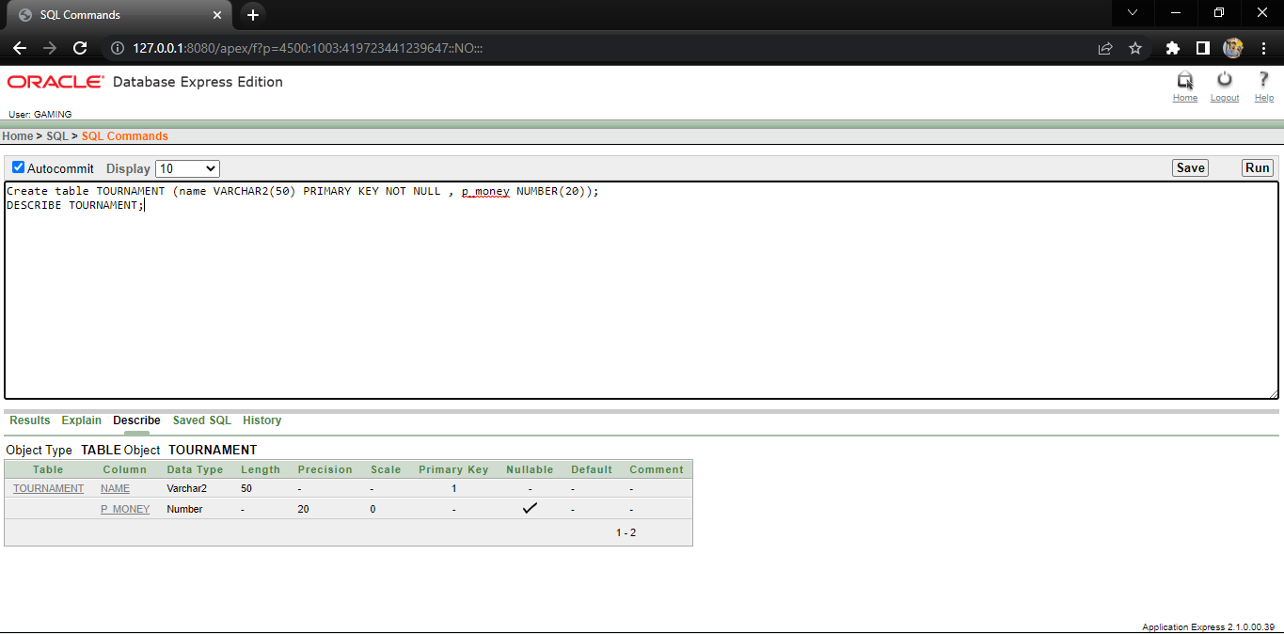

* **HIRE:**

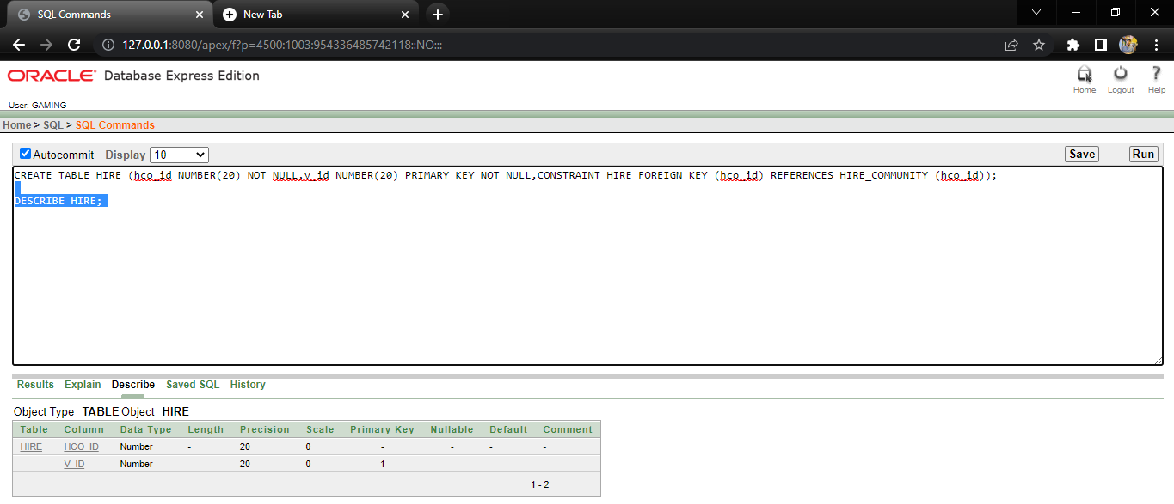

* **PUBG_TEAM:**

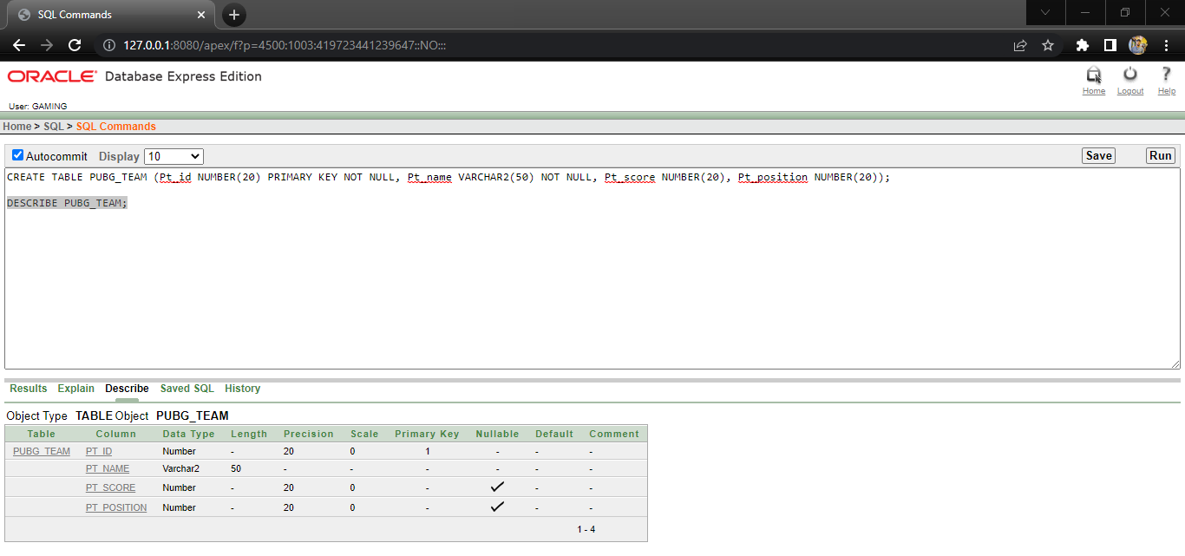

* **CALL_OF_DUTY_TEAM:**

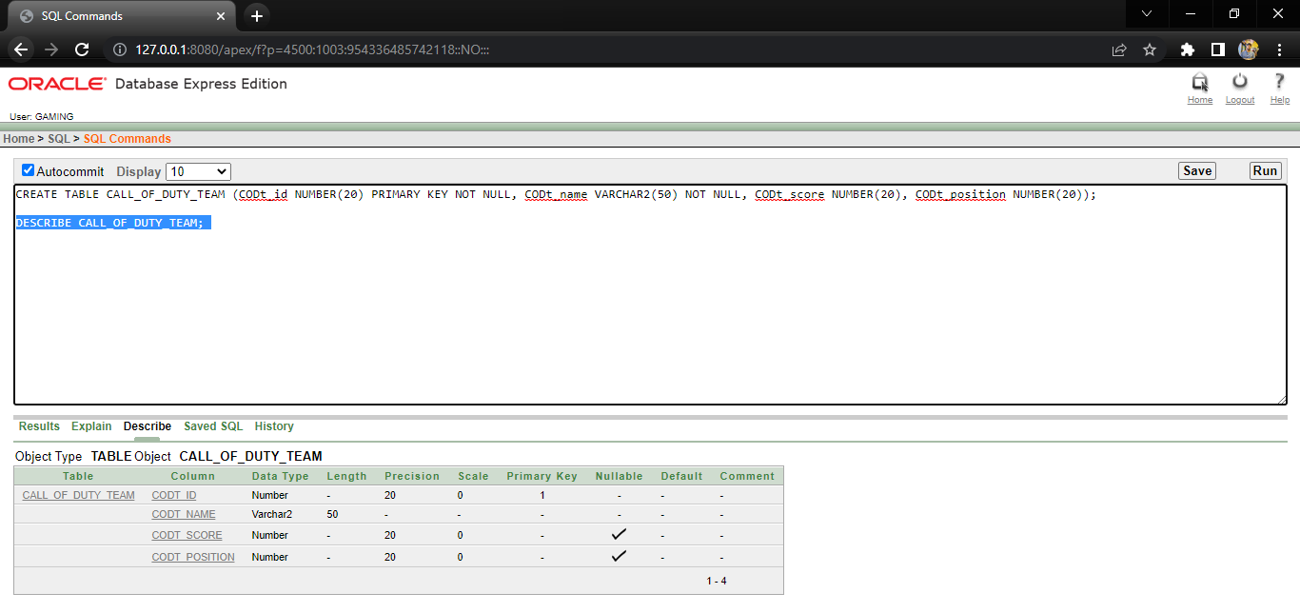

* **CALL_OF_DUTY:**

* **GUIDE:**

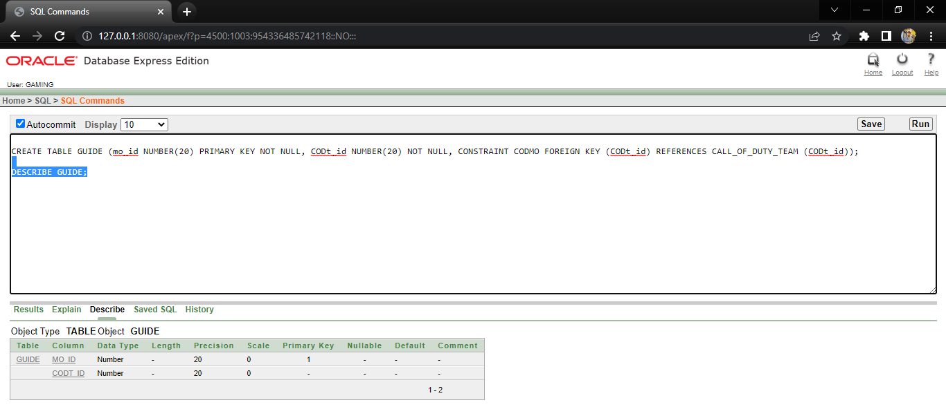

* **OTHER_COMMUNITY:**

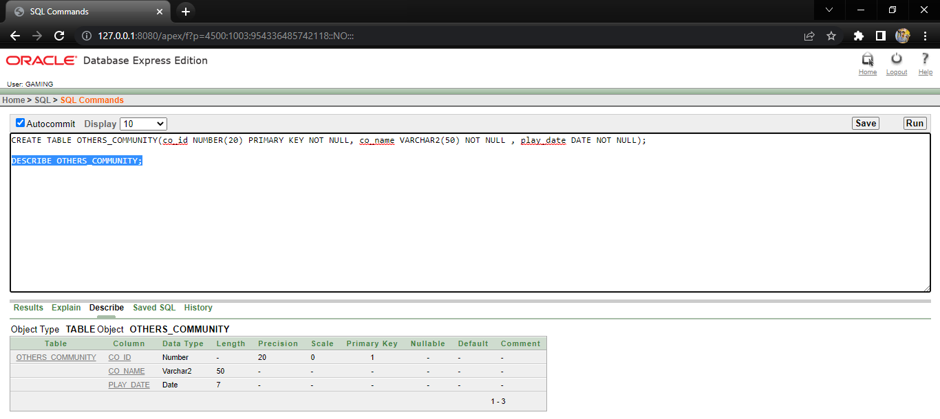

* **MERIT:**

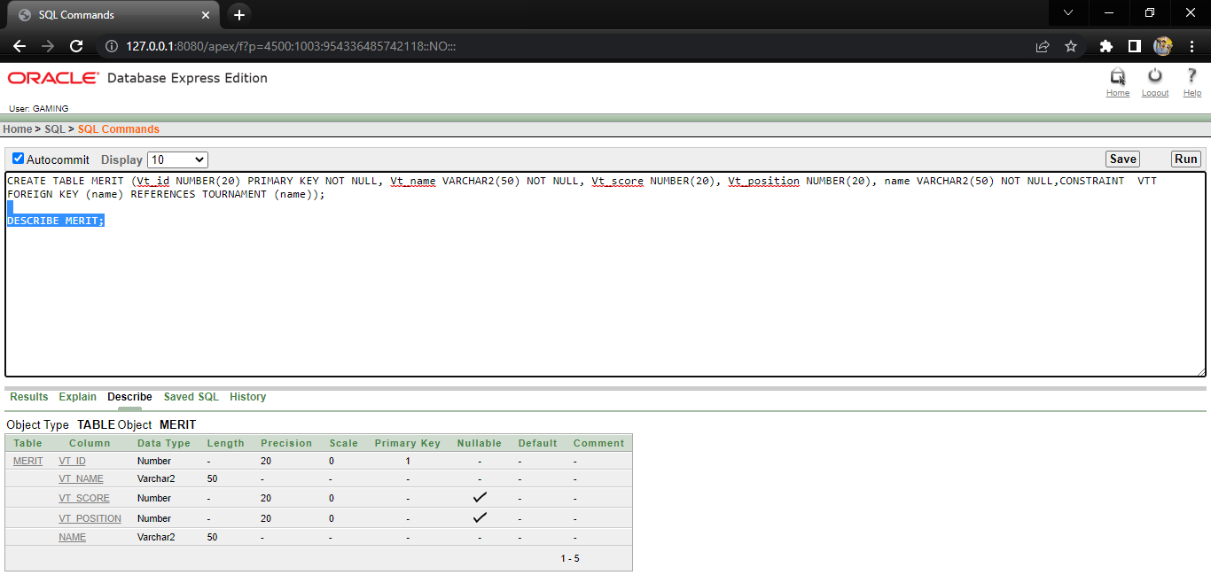

* **VALORANT_TEAM:**

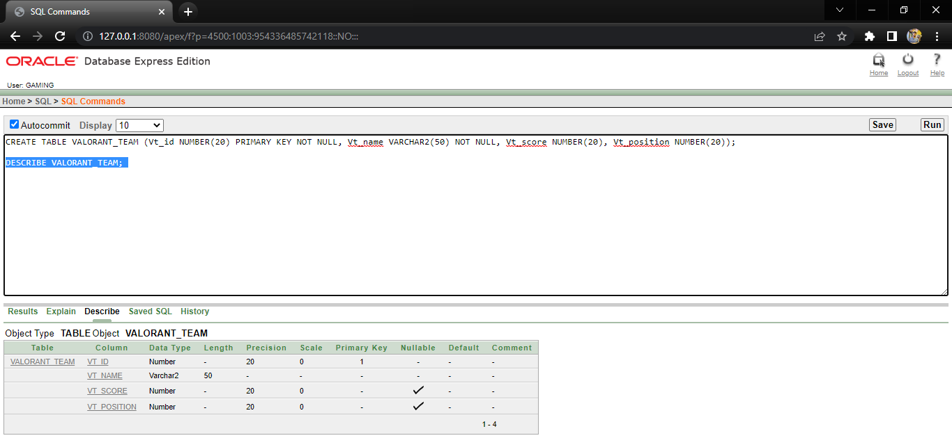

* **TECHNIQUE:**

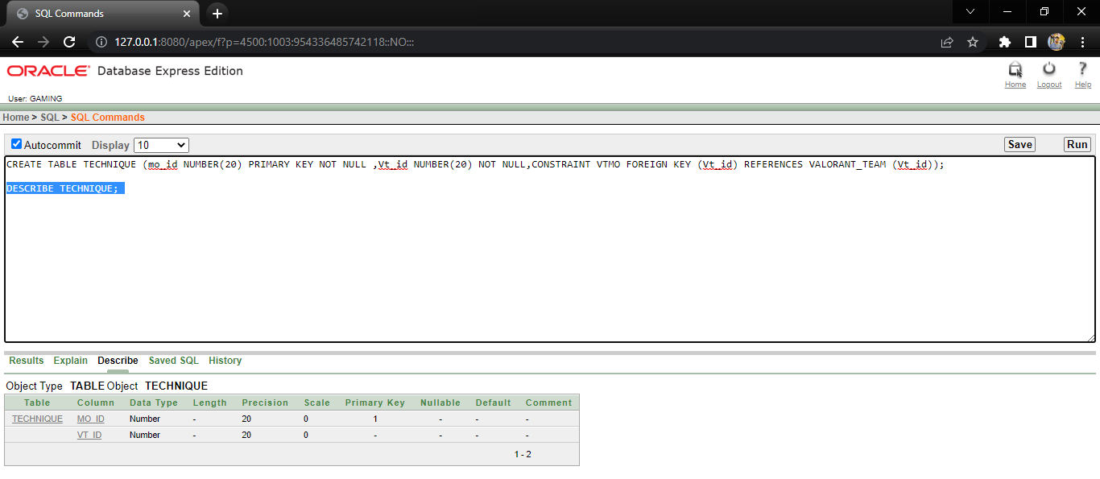

* **PERMISSION:**

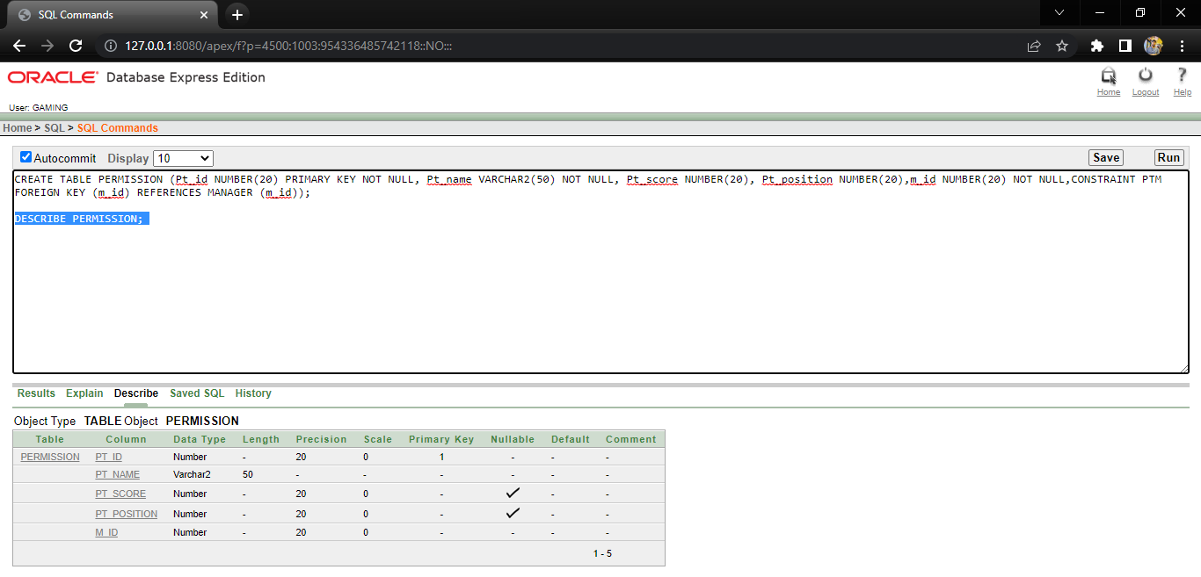

* **SPORTS:**

* **CREATE_COD:**

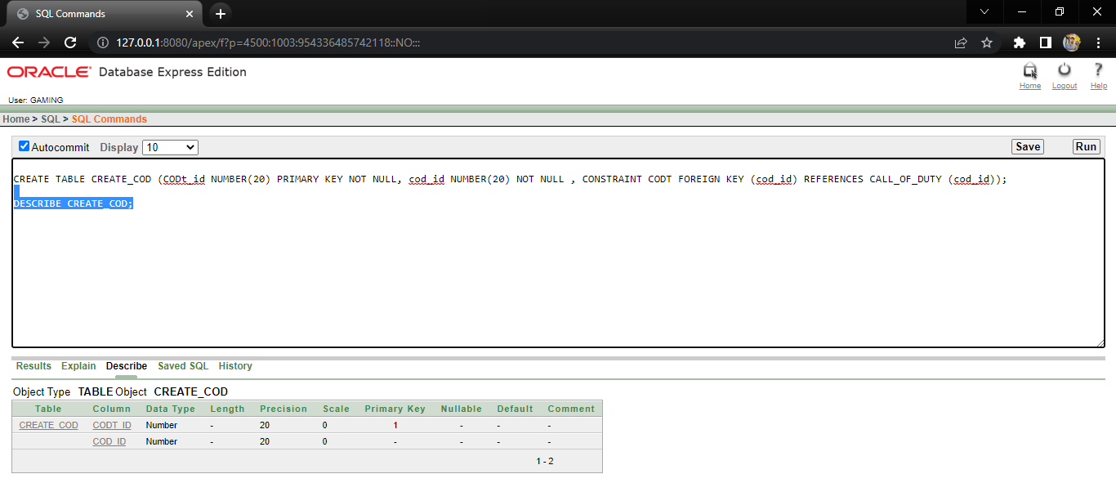

* **CHECK_PUBG:**

* **CHECK_VALORANT:**

* **CHECK3:**

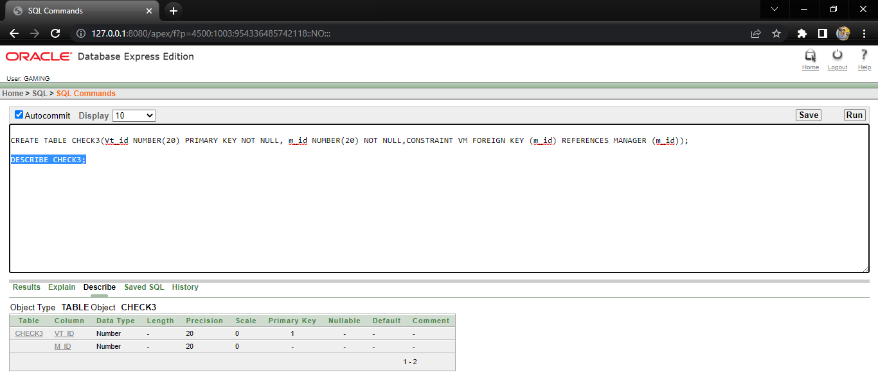

* **COMPETE:**

* **MANAGER:**

* **MODERATOR:**

* **TRICK:**

* **COUNSELLOR:**

* **CHECK4:**

* **HIRE_COMMUNITY:**

* **QUALIFY:**

* **BATTLE:**

* **VALORANT:**

* **CONTEST:**

* **FUN:**

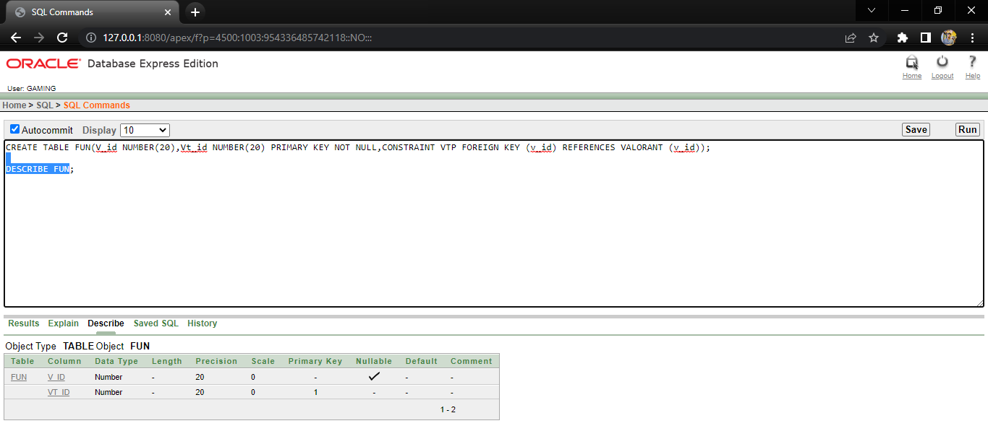

**Data Insertion**

* **VALORANT_TEAM:**

* **VALORANT:**

* **TRICK:**

* **TOURNAMENT:**

* **TECHNIQUE:**

* **SPORTS:**

* **QUALIFY:**

* **PUBG_TEAM:**

* **PUBG:**

* **PERMISSION:**

* **OTHERS_COMMUNITY:**

* **MODERATOR:**

* **MERIT:**

* **MANAGER:**

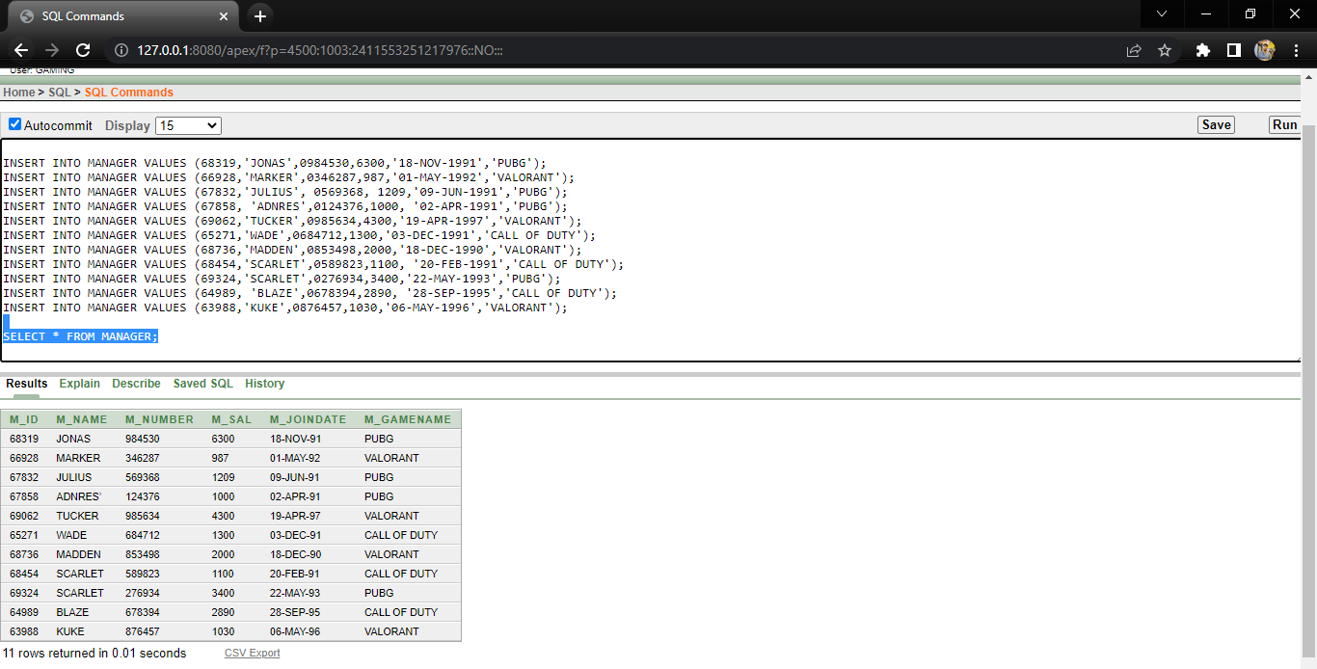

* **HIRE_COMMUNITY:**

* **HIRE:**

* **GUIDE:**

* **FUN:**

* **CREATE_COD:**

* **COUNSELLOR:**

* **CONTEST:**

* **COMPETE:**

* **CHECK4:**

* **CHECK3:**

* **CHECK_VLORANT:**

* **CHECK_PUBG:**

* **CALL_OF_DUTY_TEAM:**

* **CALL_OF_DUTY:**

* **BATTLE:**

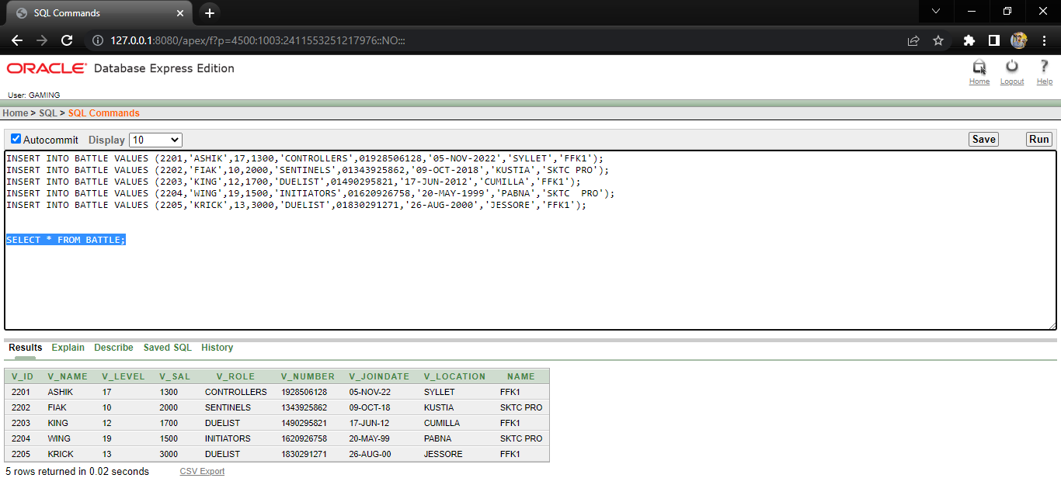

**Query Test**

**Single Row Query**

* Display the Valorant player id, sal, joindate and location for all players who has name is KING.

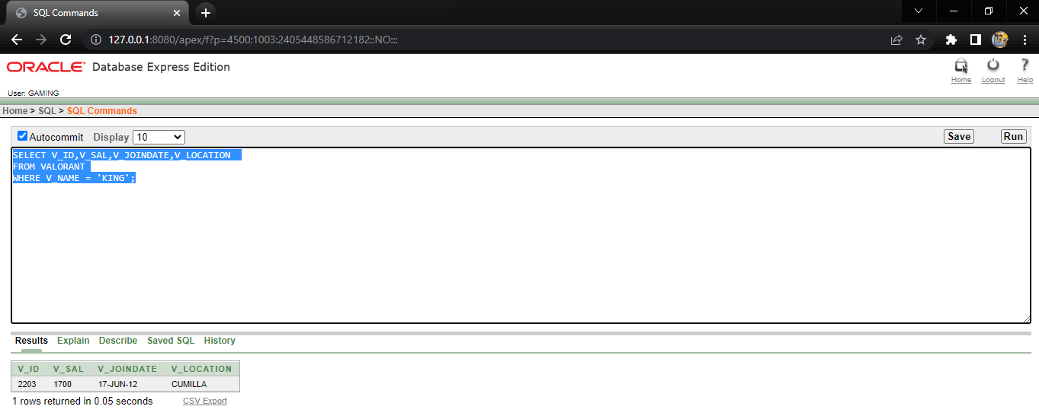

**Aggregate Function Query**

* Display the moderator’s minimum salary where minimum salary greater than 50 and group by game name.

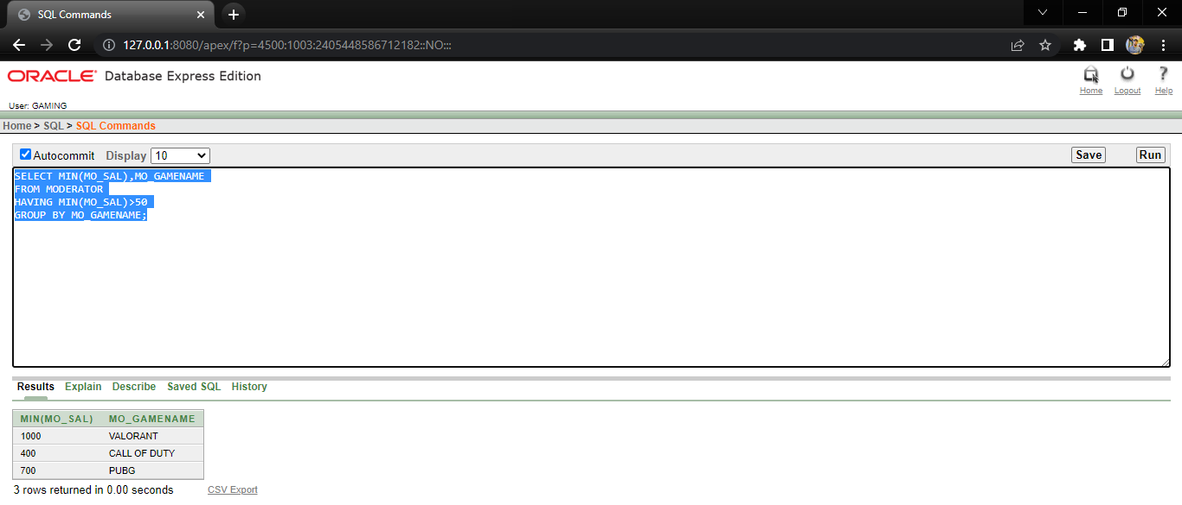

**Single Row Sub Query**

* Write a query to display the manager’s name, game name and hiredate for all managers in the same game name as Wade. Exclude wade.

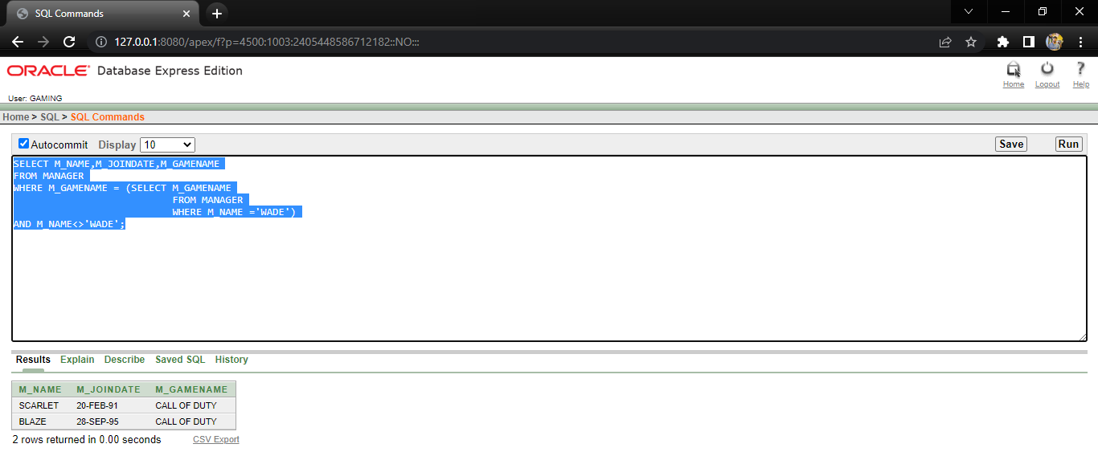

* Display the pubg player id, name, and salary for all the players who earn more than the average salary and who work in a name with any player with a T in their name.

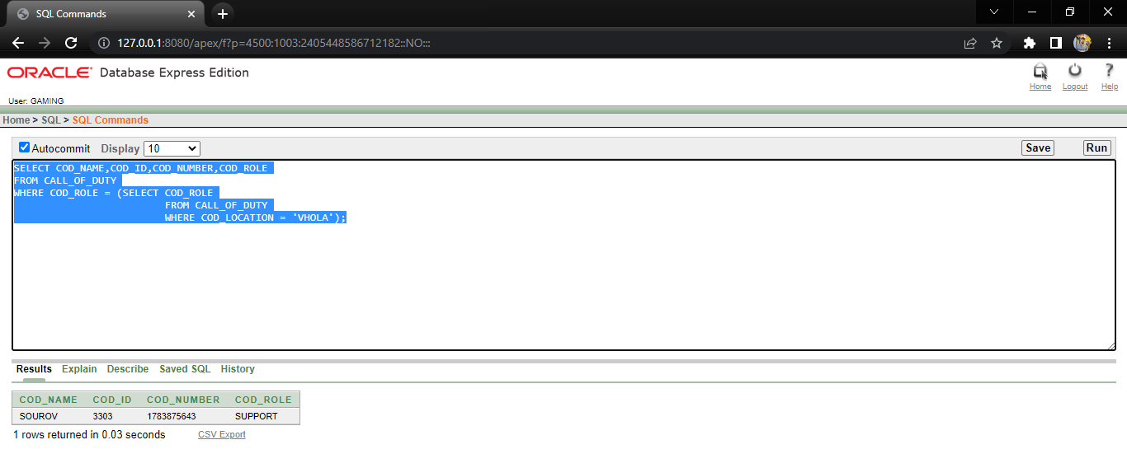

**Multiple Row Sub Query Test**

* Write a query to display the pubg player id and name for all pubg player who play in a role with any players whose name contains a J.

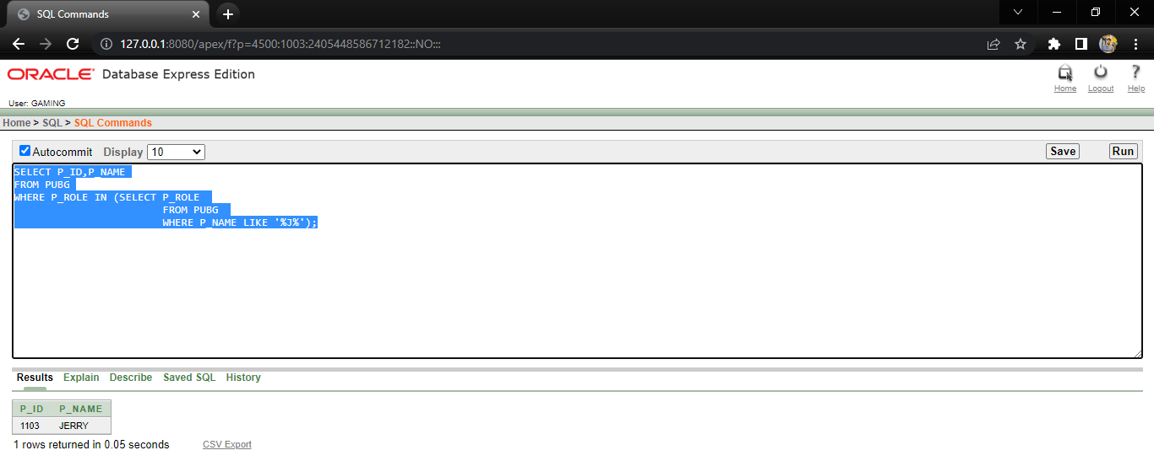

* Display the pubg player id, name, and salary for all the players who earn more than the average salary and who work in a name with any player with a T in their name.

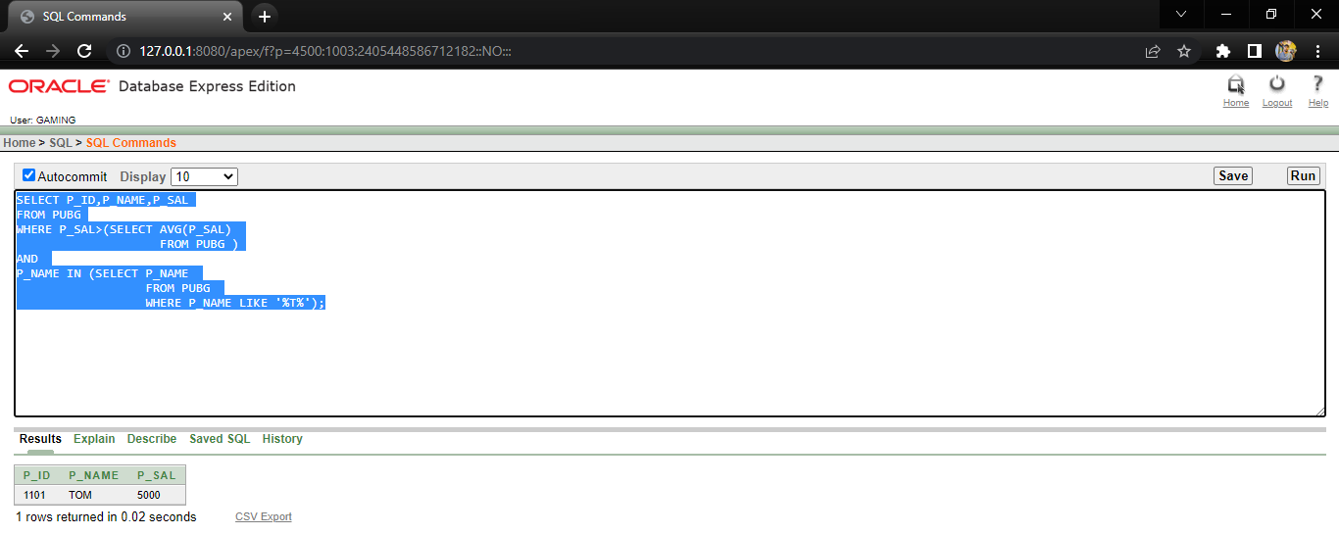

**Equi Join**

**Joining**

* **Write a sql query display all the valorant team id and name whose are qualify in a tournament.**

**Outer Join**

* **Write a sql query display all the valorant player and community name whose were hired date between ’20-APR-1998’ TO ’08-DEC-2017’.**

**Self-Join**

* **Write a Sql query to find the manager and moderator name, id and salary whose game name are same.**

**View**

* **Create a view to display all the pubg player name,salary,team id and moderator name,id from PUBG,PUBG TEAM and Moderator table .**

* **Show all the Data from PUBGINFO Table.**

* **Create a view to display all the pubg player name,id and salary where salary is greater than 3000 from Pubg table.**

* **Show all the Data from PUBG_BETA Table.**

**Conclusion**

Gaming community management system is not an easy role. Knowing what benefits a healthy gaming community management system brings, where to start, and how to grow, should be well on your way to creating and facilitating a successful gaming community management system. Remember the double-edged sword of responsibility: regular content provision and careful moderation of gaming communities are equally important to keep the community system alive and safe.

Games won't go as far as they should without a proper gaming community management system. TransPerfect Gaming Solutions helps establish, build, and connect gaming community management systems in a way that conveys vision and provides the support needed to enhance the overall gaming experience of players.

Maintaining relationships between players, providing timely feedback, and implementing marketing strategies, among many other tasks are required for great gaming community management system.

Finally, it helps to maintain player and community system. Our target is reach to others people they are use this system and make a good community system.